1. Start studies with Key Concepts
2. No advanced approvals nor electronic signature on exam

Sales Cycle - start

1. Product Configuration - a) choose single product, b) guided selling, and c) Bundles
2. Pricing and Discounting - happens on quote object
3. Quotes and Proposals - templates for quotes
4. Electronic Signature - DocuSign or EchoSign
5. Contract - used for subscriptions along with Assets
6. Add On Quotes and Orders
7. Renew Contract –
8. Create Opportunity

Sales Cycle - end

1. You can have many quotes to one opportunity but only one quote is primary
2. Only support one price book for a quote/opportunity
3. Always add Start Date and Term to Quote
4. 4 Focus Areas of Study - Products and Bundles 32%, Pricing and Discounts 39%, Quote Templates 15%, and CPQ Platform 15%
5. Know Asset Conversion Selection Options on Product  
   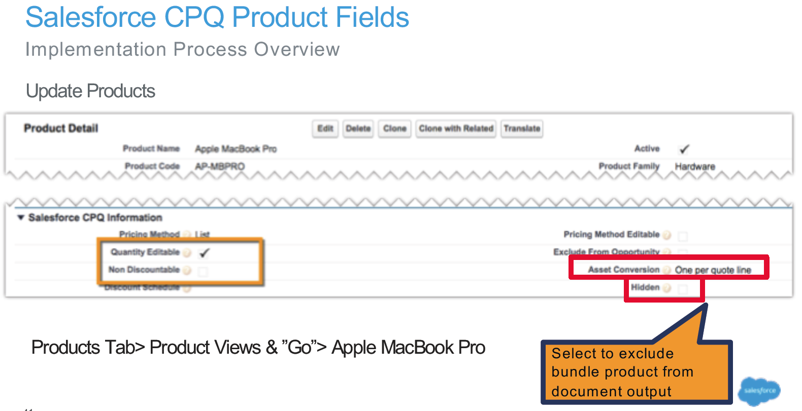
6. Asset conversion selection options (ie None, One-per-quote line and One-per-unit)
7. Know Quantity Editable, Non- Discountable and Hidden checkboxes on the Product  
   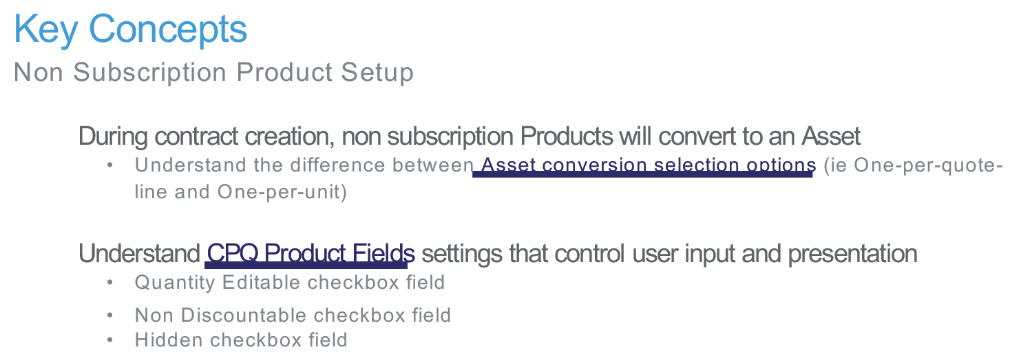
8. Hidden checkbox is to exclude bundle product from document output
9. Prorate calculation is good up to 4 decimal places
10. Know Subscription Prorate Precision and Subscription Term Unit in Package Settings for Subscriptions and Renewals  
    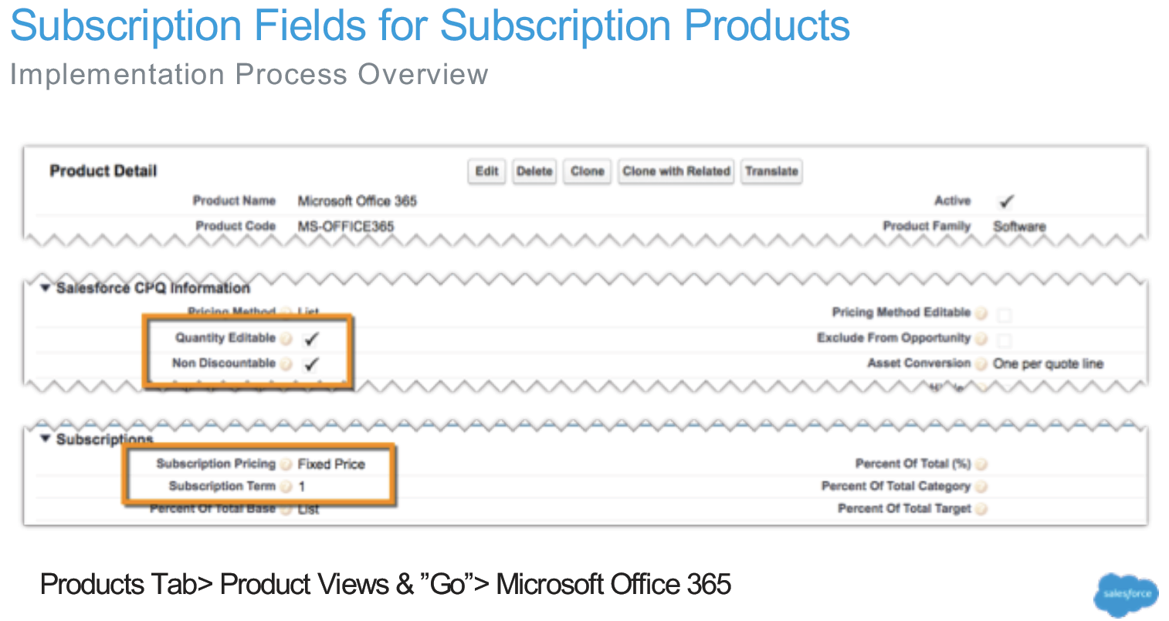
11. Know Subscription Fields for Percent of Total Products (POT) – During contract creation, subscription products will convert to subscription records
12. Know Subscription Pricing picklist value meanings on Product
13. Know Subscription Term on Product  
    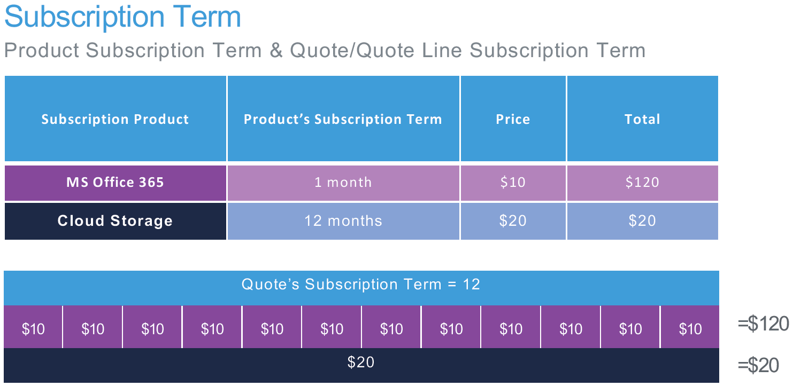  
    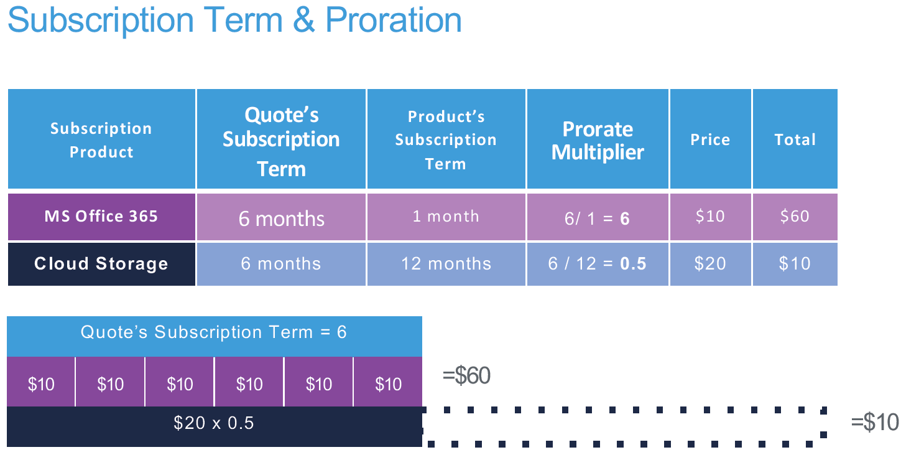
14. Know None renewal product setup  
    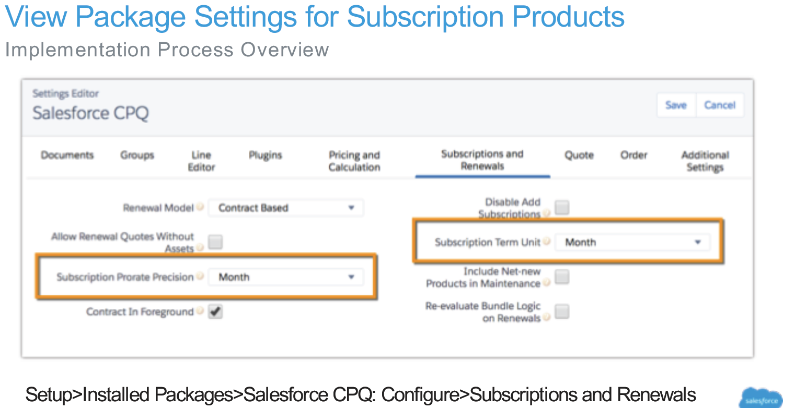  
    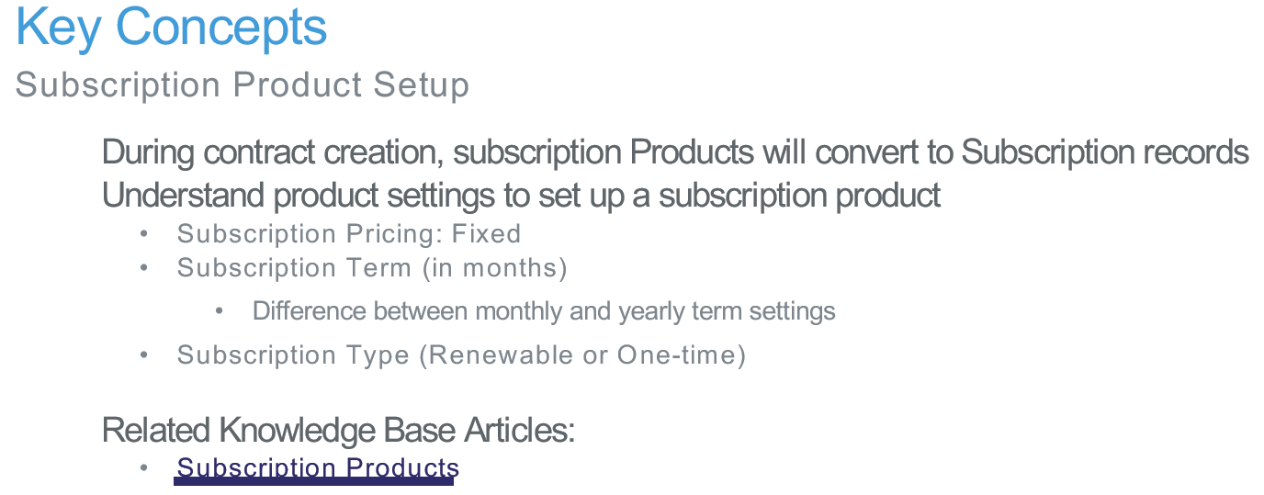

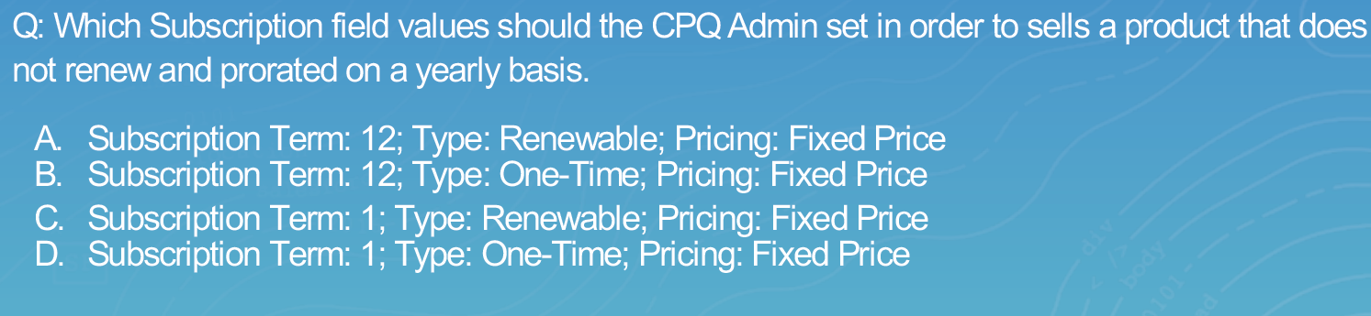  
Answer B

1. Percent of Total is not stackable. You cannot have a product with a Percent of Total feed off another product with Percent of Total  
   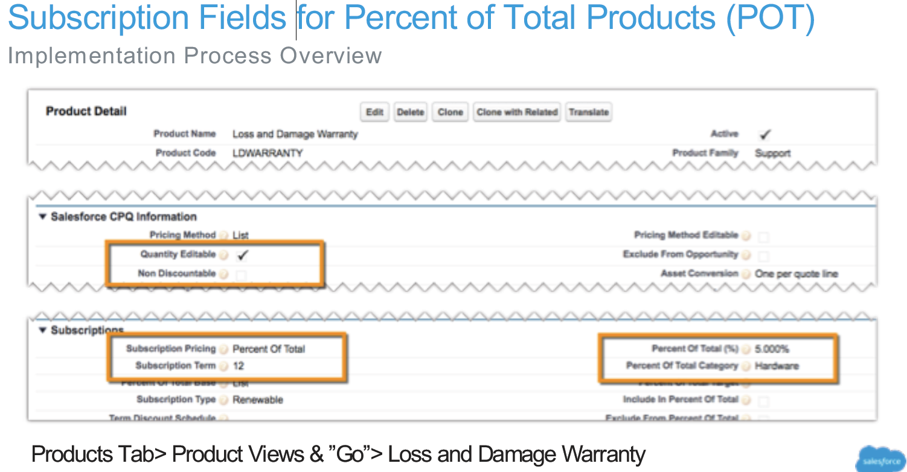  
   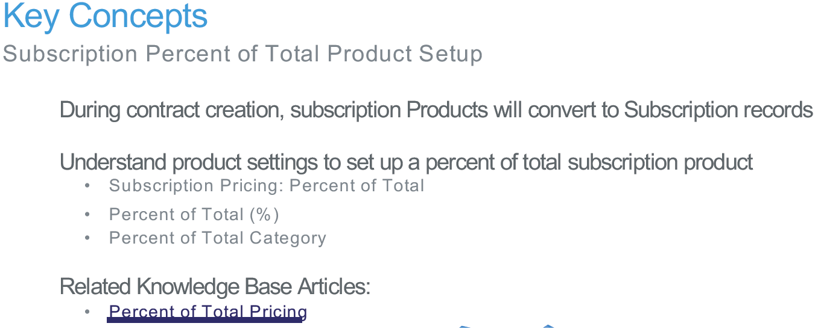

Bundles

1. Configuration Event Variations – Configuration Type and Configuration Event fields on Product object
2. Use Configuration Event Variation Summary slide when deck is sent. Most common is Allowed and Always are the best practice settings. None and None are the same as Allowed and Edit.  
   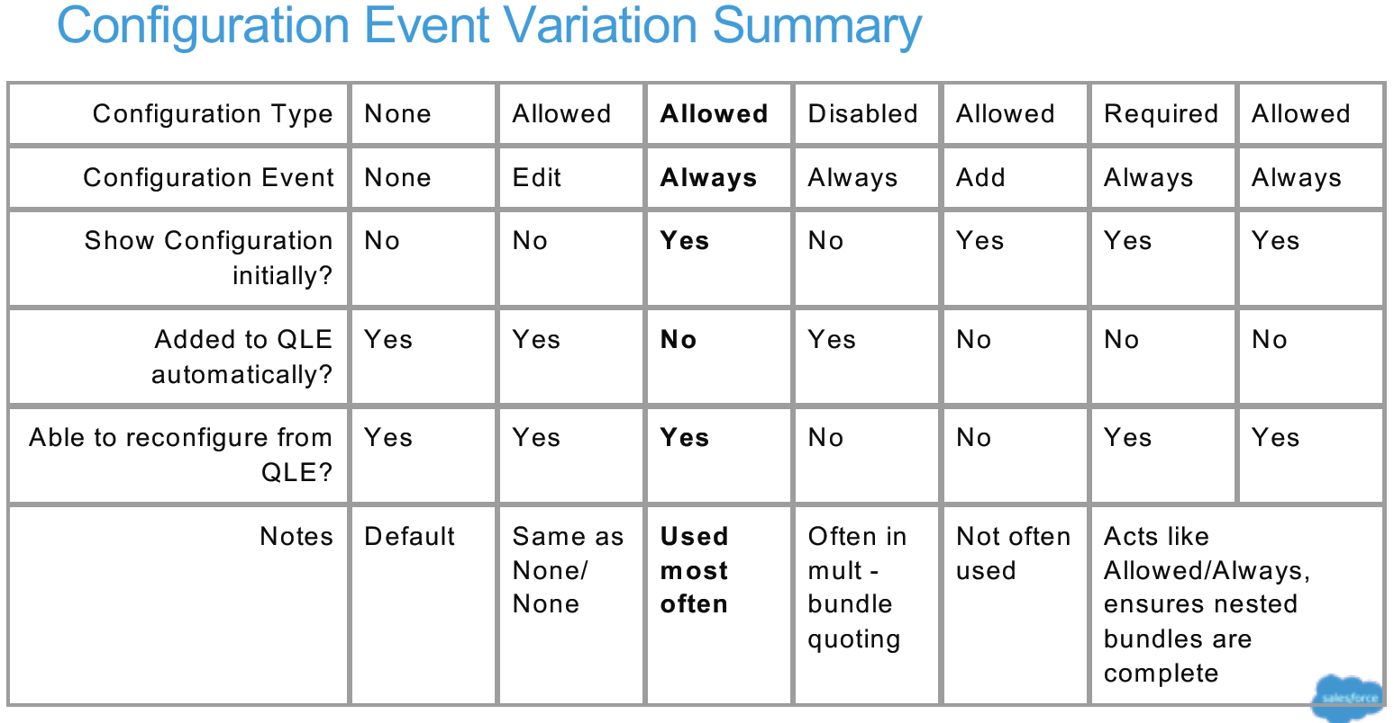  
   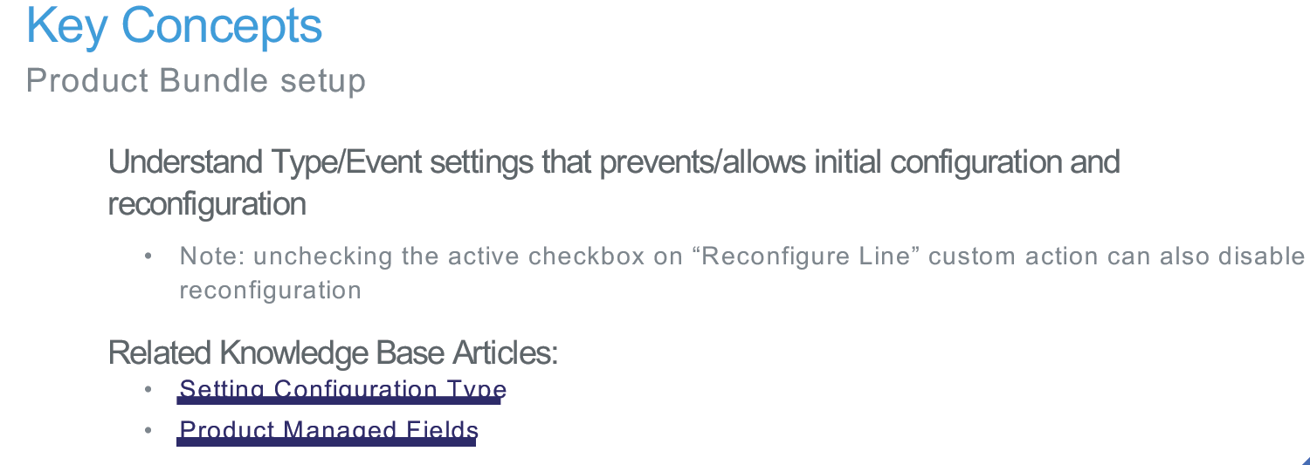

Features

1. Fields – Name, Number, Configured SKU, Min Options, and Max Options. Know these.  
   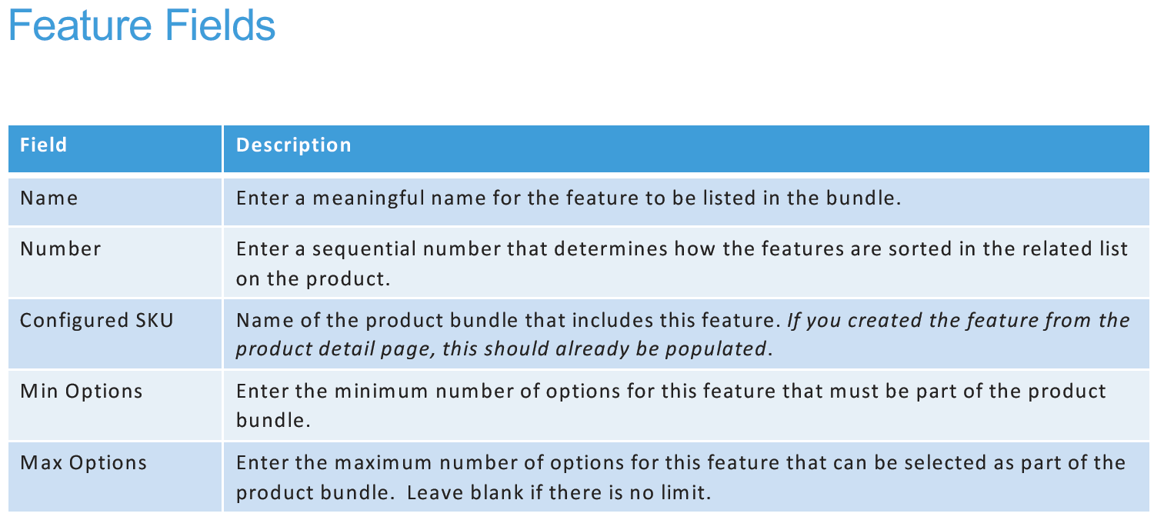
2. Max Options = 1 will make it so that you can only select one option in a Feature
3. Know how the number field controls the feature order
4. Know the min/max functions control user selection
5. Category setting allows for another level of organization of the feature  
   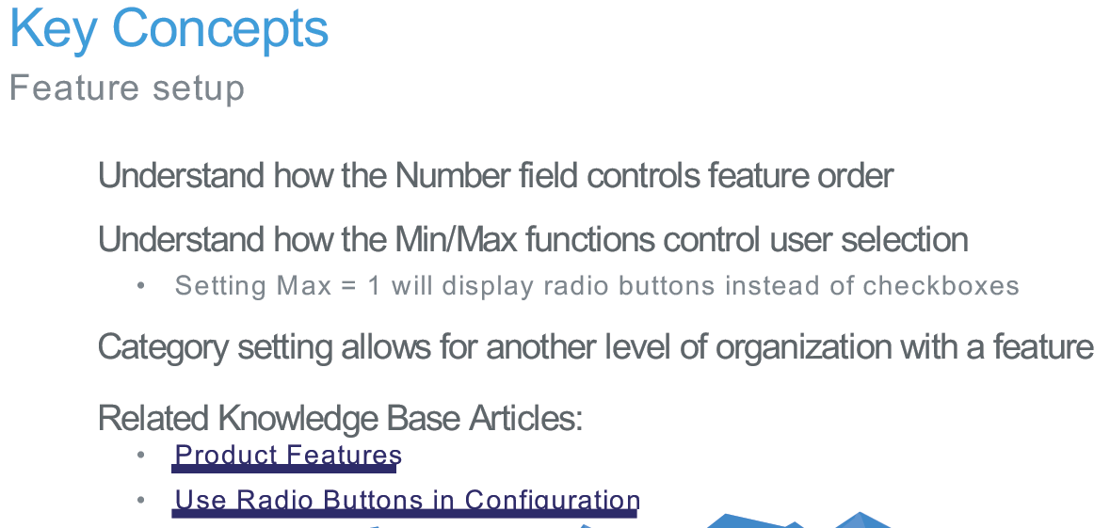

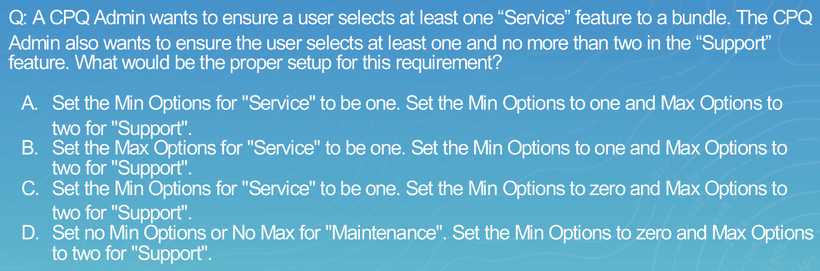

Answer: A

Options

1. Fields – Optional SKU, Bundled, Required, Selected, and Type (Component, Related Product, Accessory, None)  
   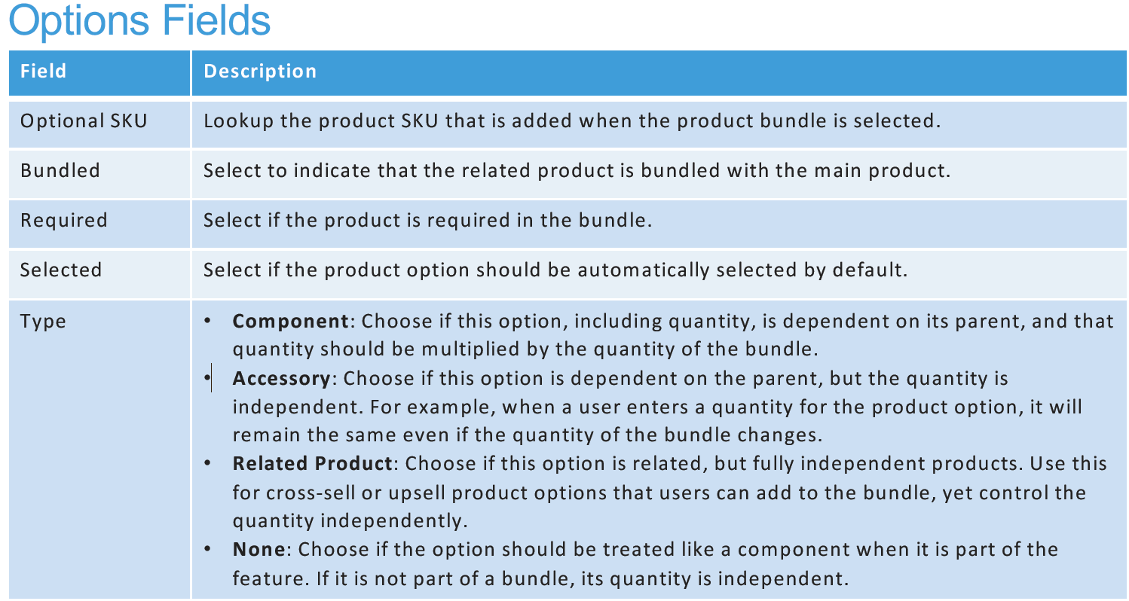  
   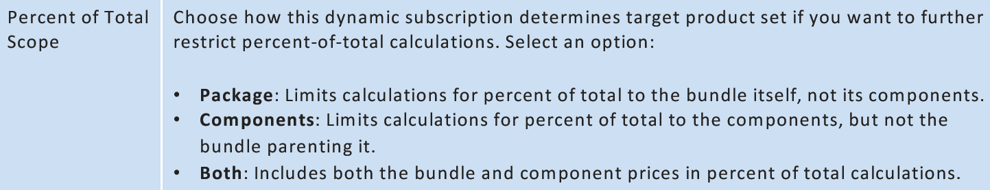
2. Type controls how the quantity for options is affected by Bundle quantity  
   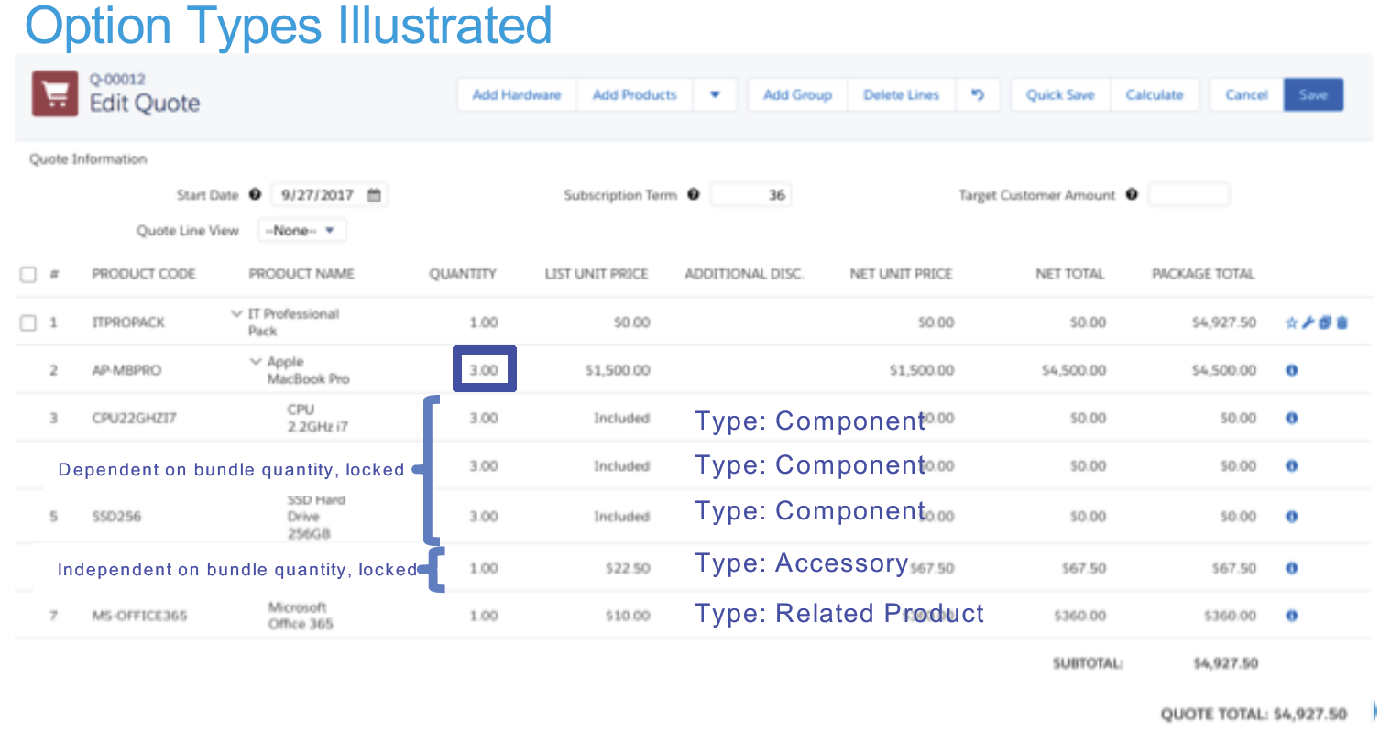
3. Many questions on the exam will go over the assembly processes for products, etc
4. Bundled checkbox will show List Price as Included and Newt Price as $0
5. Apply Immediately will trigger rules to run after selection
6. Try : changing Option Selection method from Click to Add on the bundles, the production collapses options
7. Exercise 5 in guide  
   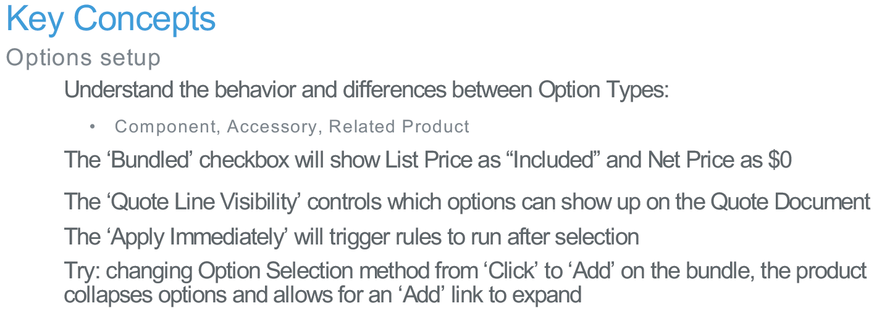  
   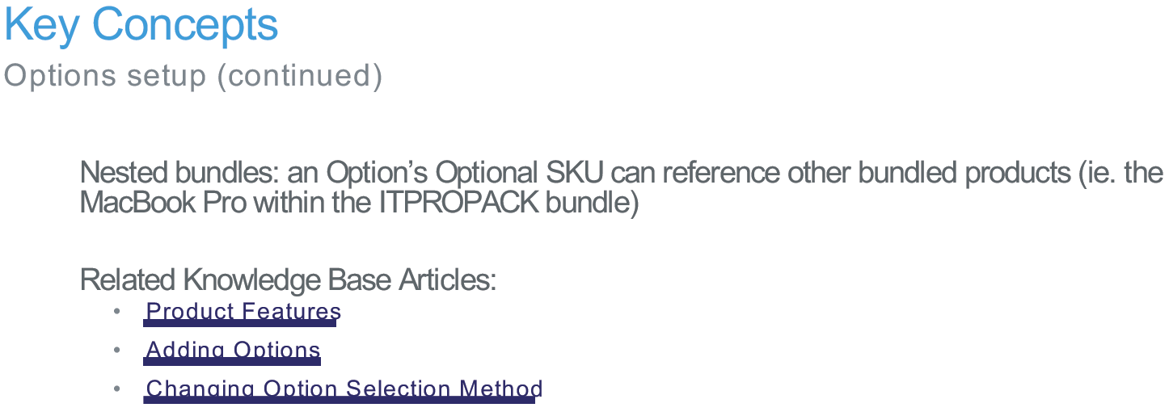

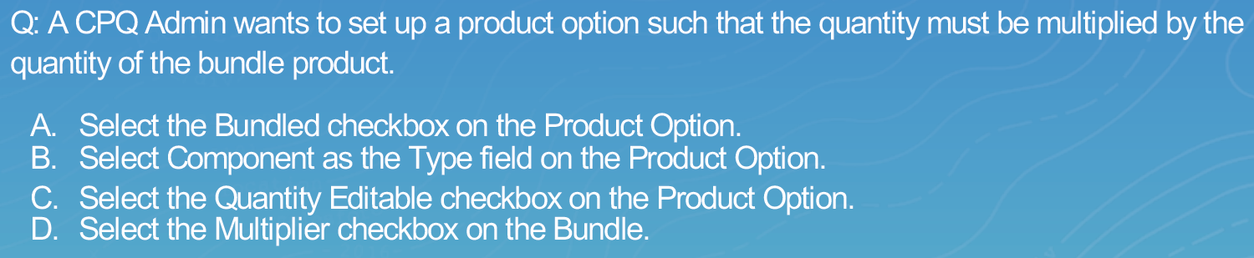

Answer: B

Configured Code Pattern

1. A string that can be used to pass to outside systems for a bundled product  
   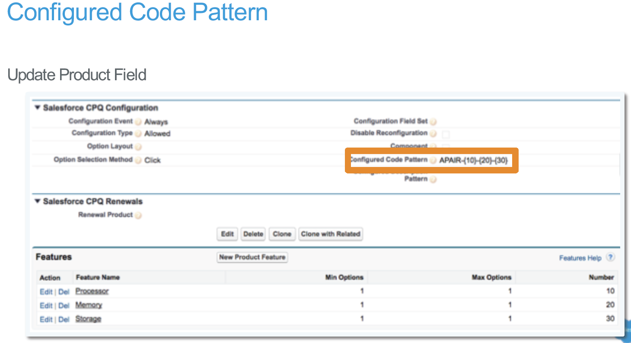
2. Set Component Code and Component Code Position on the Product to set this up.  
   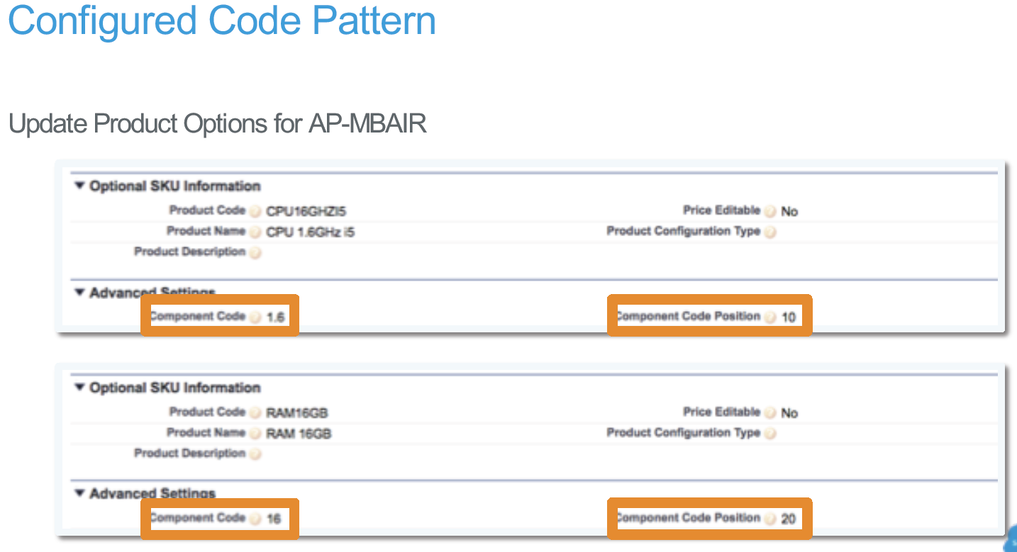
3. There is also a Product Description Pattern but works similarly as the Configured Code Pattern  
   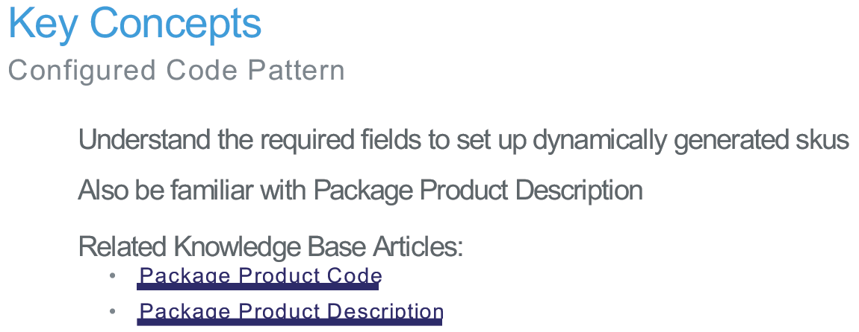

Option Constraints

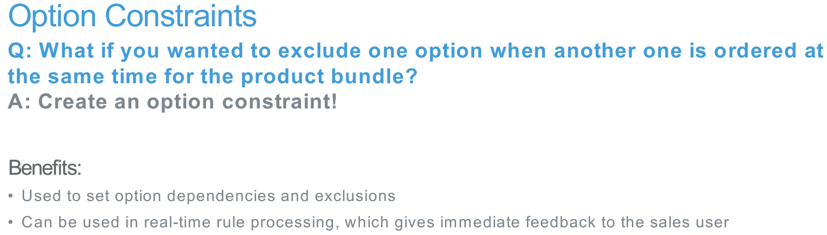

1. Used to set option dependencies and exclusions
2. Can be used in real-time rule processing, which gives immediate feedback to the sales user
3. Configured on the Product Related List entitled Option Constraints
4. Fields – Constraint Name, Constrained Option, Constraining Option, Active, Configured SKU, and Type  
   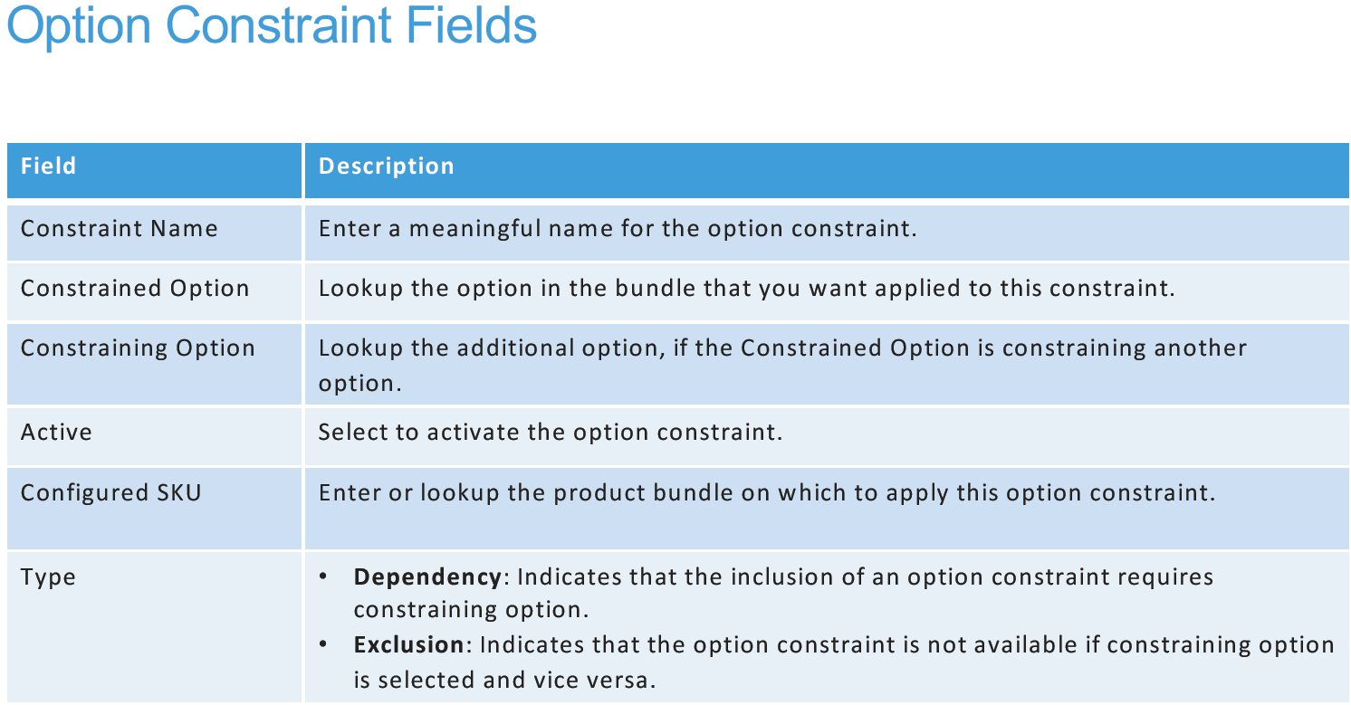
5. Exercise 6 & 7 in guide
6. Option Groups  
   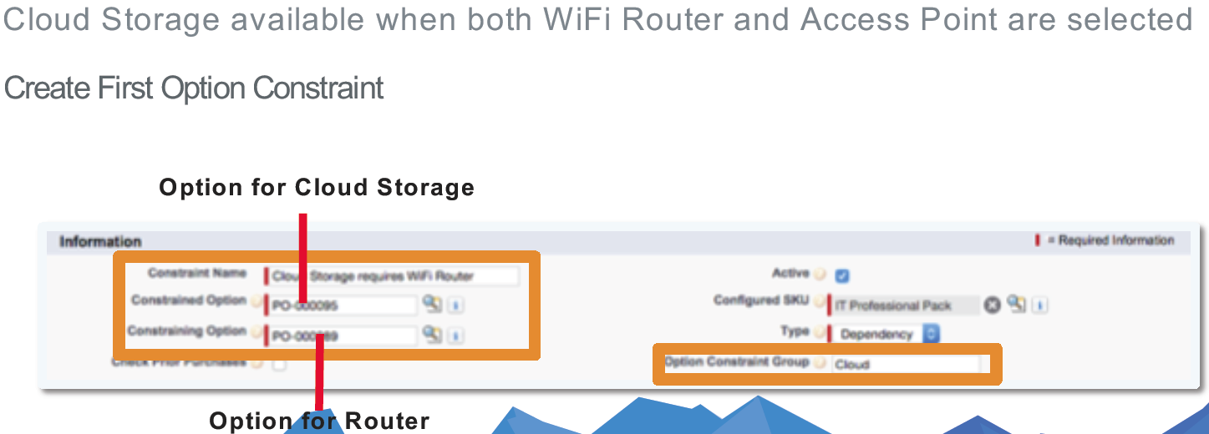  
   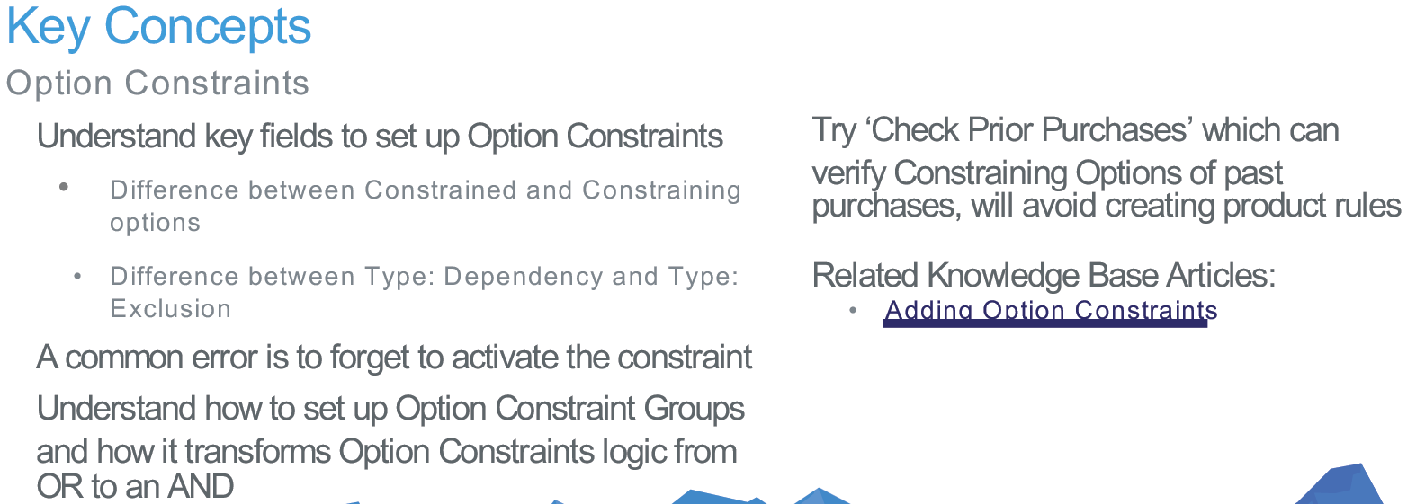

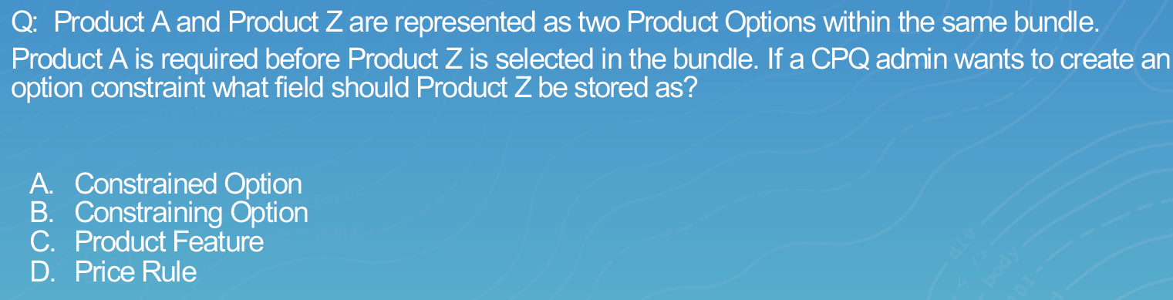

Answer: A

Product Rules

1. Create Product Rule and add Configuration Rule 🡪 Create Error Condition 🡪 Create Actions 🡪 Update Product Option
2. Fields – Type, Active, Product Rule Name, Conditions Met, Scope, Evaluation Event  
   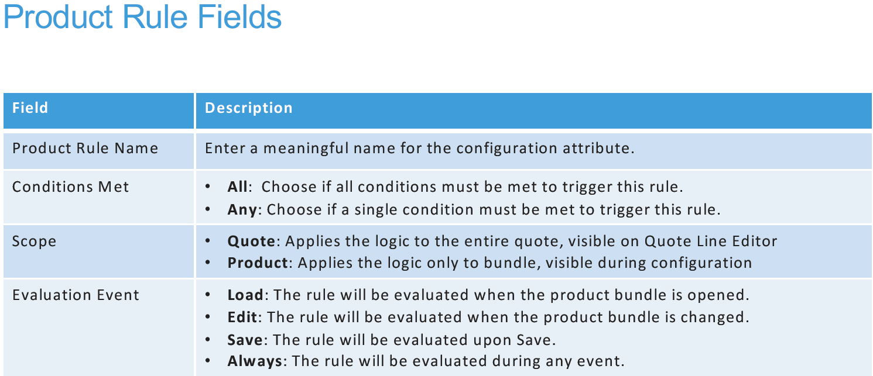  
   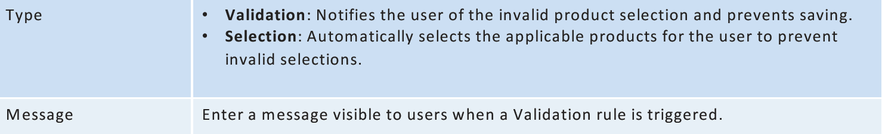
3. Must have a Configuration Rule, it is the junction object
4. Create Error Condition on Product Rule object 🡪 Need Rule, Tested Object, Tested Field, Operator, Filter Type, Filter Value  
   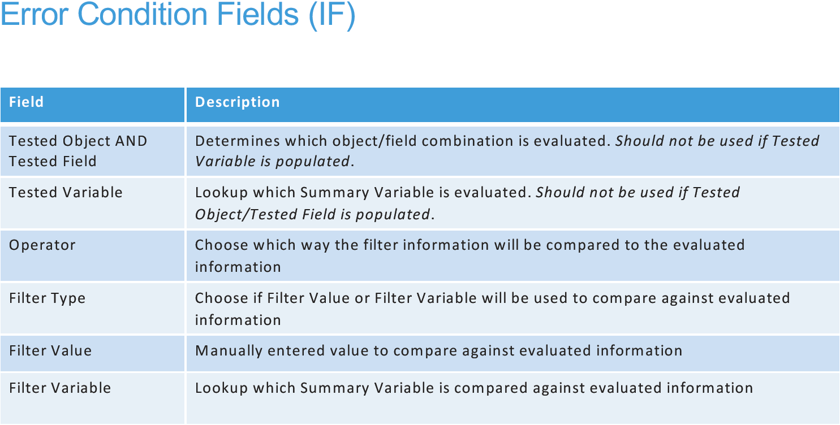
5. Create Action on Product Rule object 🡪 Need Type, Product, Required  
   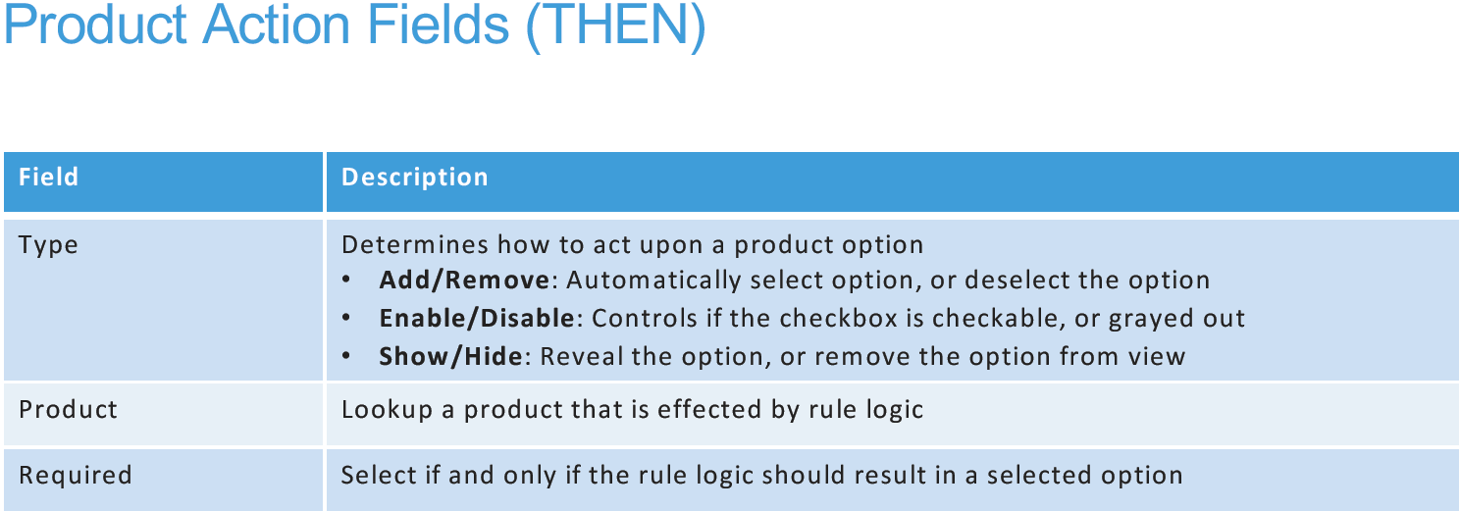
6. On Product Option check the box for Apply Immediately. Best practice is whenever there are rules on a product option  
   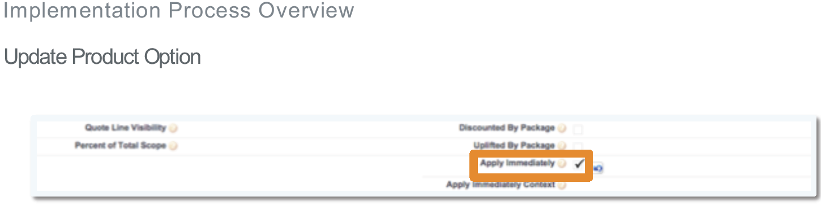  
   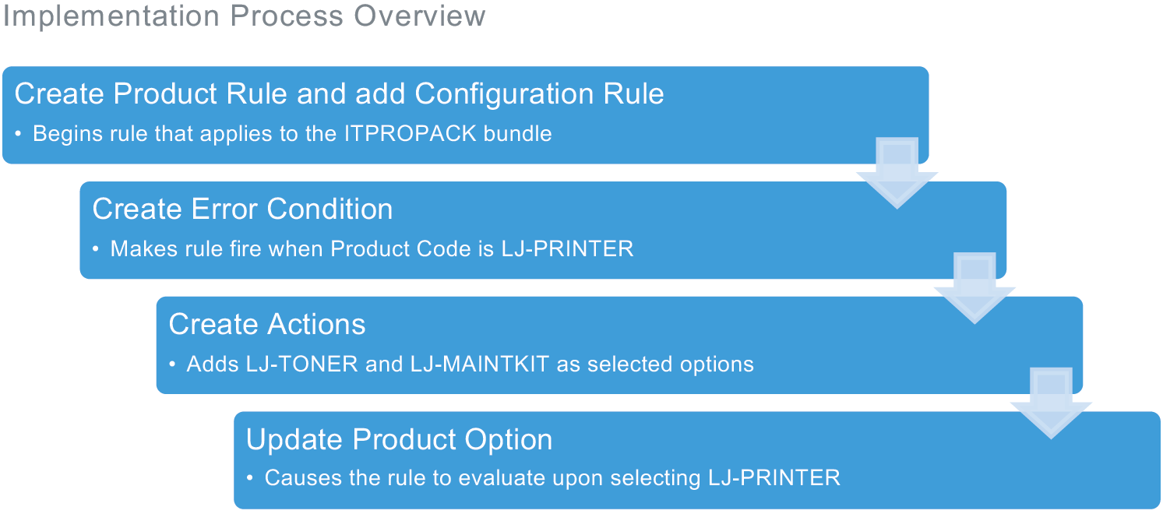  
   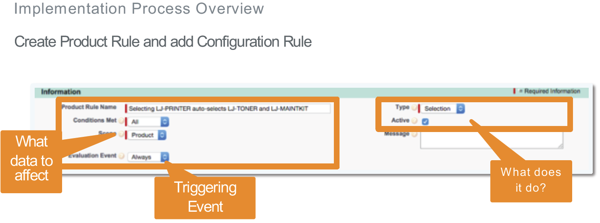  
   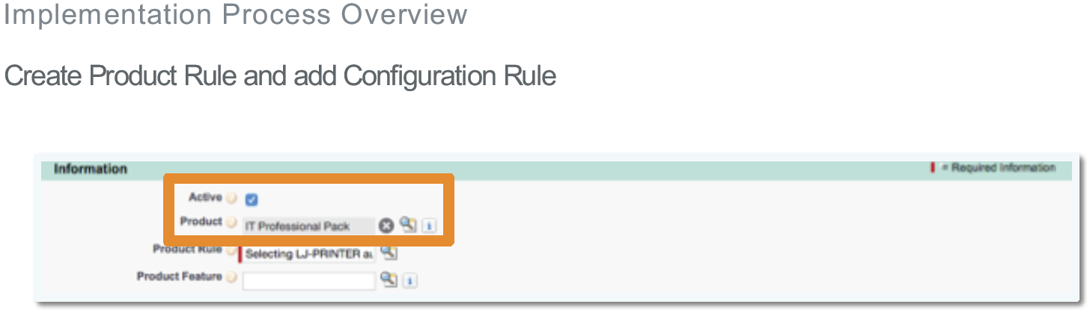  
   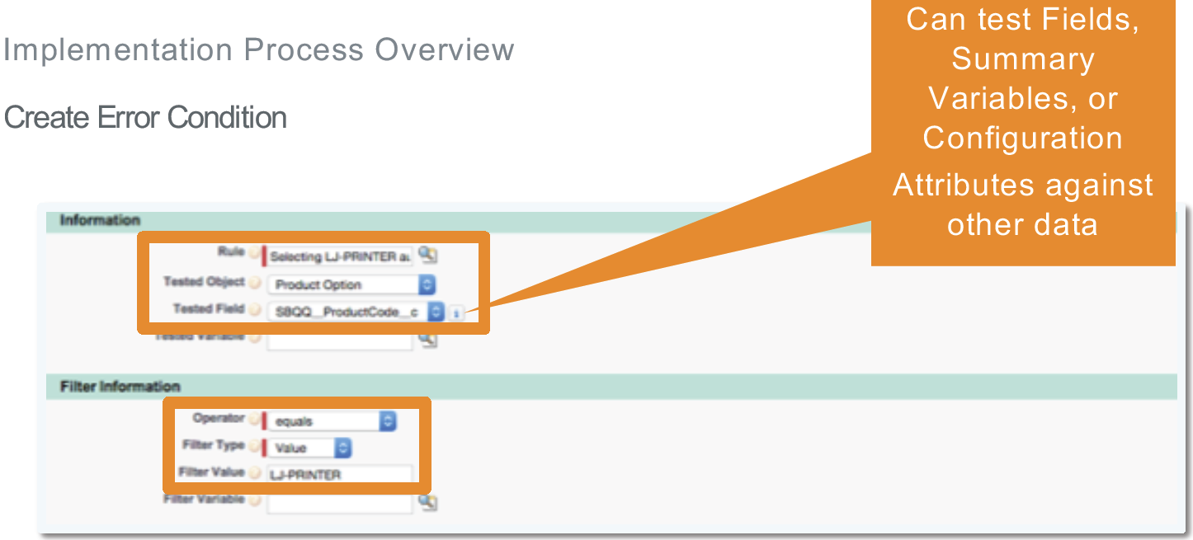  
   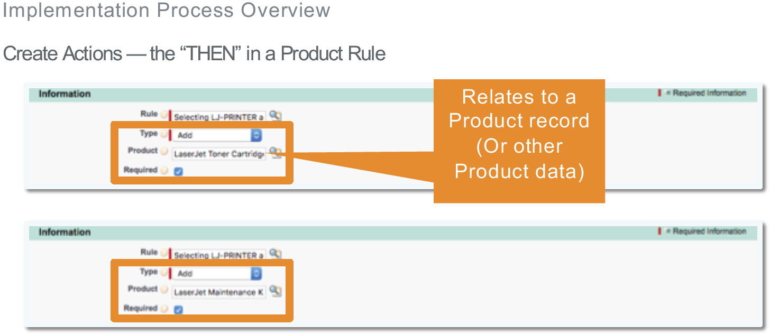

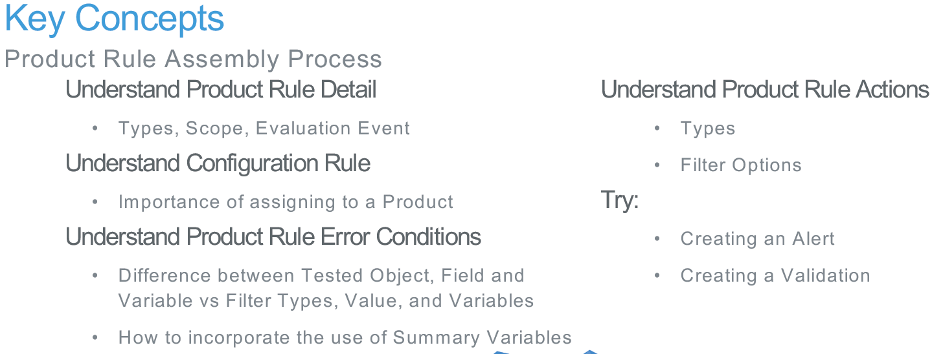

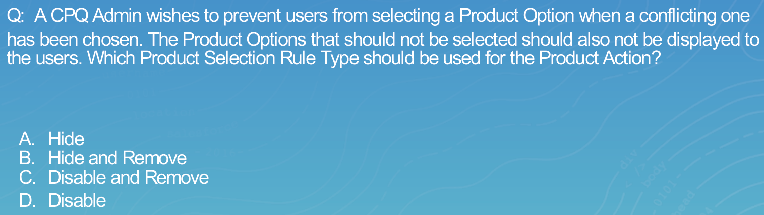

Answer: B

Configuration Attributes

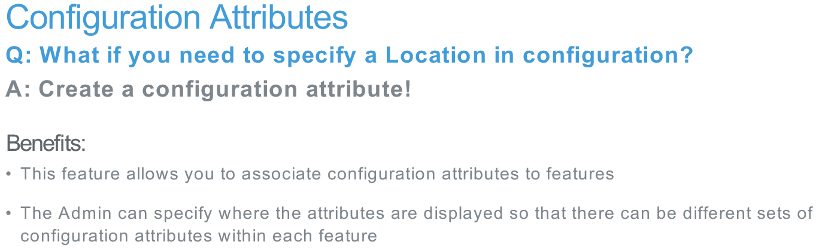

1. What if you need to specify a Location in configuration? Create a configuration attribute!
2. This feature allows you to associate configuration attributes to features.  
   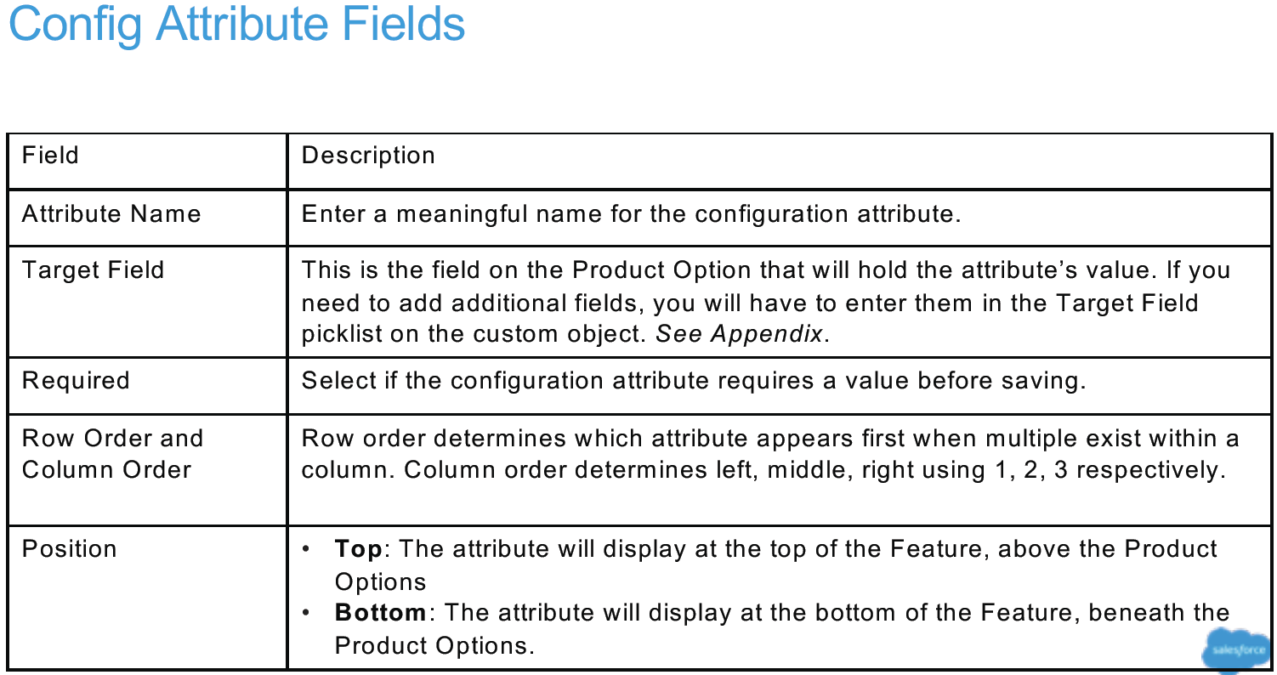  
   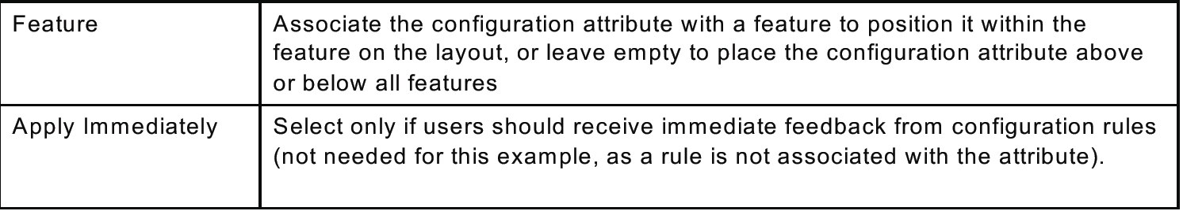
3. Create Config Attribute process: Create Product Option picklist fields 🡪 Create Config Attributes 🡪 Create Quote Line picklist fields  
   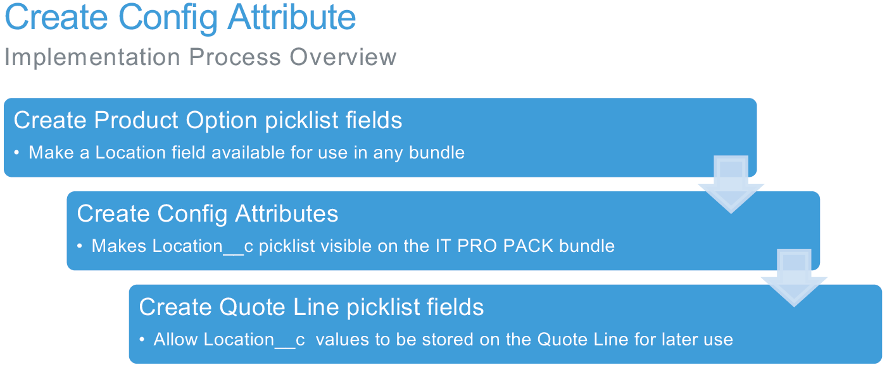
4. Definitely read the Auto-Mapping (Twin Fields) knowledgebase article on the partner site

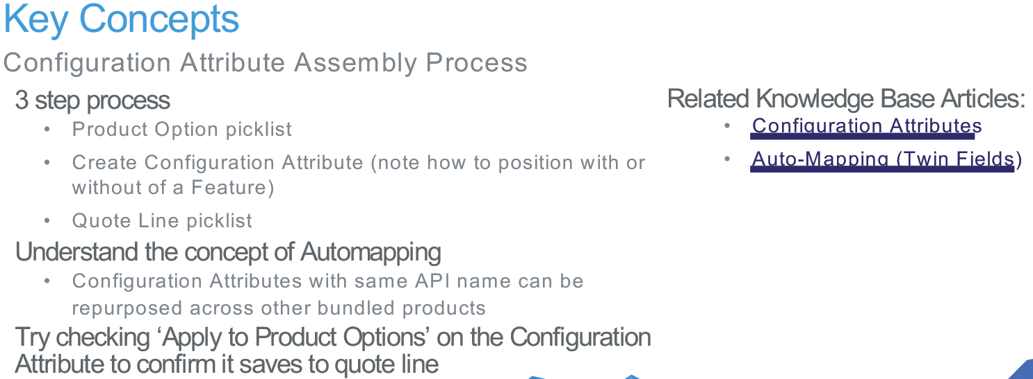

Custom Actions

1. Basically a button
2. Process – Create New Labels 🡪 Create custom Action Record 🡪 Create Search Fiotlers
3. Dynamic Custom Actions are not on the exam
4. Understand what the Hidden field does.

Guided Selling

1. Create Product Fields 🡪 Update Product fields 🡪 Create Process Input fields 🡪 Create Process Input Conditions

Pricing and Discounts

Pricing Waterfall

1. Original Price –> List Price minus the Discount Schedules or Contract Pricing then gives the Regular Price.
2. Regular Price minus the Additional Discount (manually entered by Sales Rep) will give you the Customer Price.
3. Customer Price minus the Partner Discount will give you the Partner Price.
4. Partner Price minus the Distributor Price give the Net Price.
5. Net Price then goes into Pipeline/Forecast Amount.
6. The waterfall pricing will be on the exam

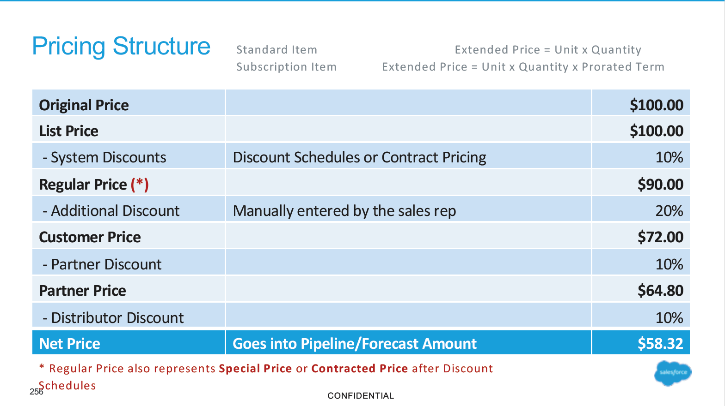

Discount Schedules

1. System Discounts.
2. Volume discounts – discounts based on quantity
3. Term Discount (multi-year discount) – discounts based on number of months
4. Cost Discount – discounts applied directly to the product cost instead of list price
5. Slide 254
6. Type – Range vs Slab slide 256. Slab breaks it up as per quantity whereas Range takes top/highest tier and applies it to all units. There will be math problems on the exam for this.
7. Aggregation Scope – None versus quote. Setting the Scope to Quote will apply the discount. Group will group all the products on the quote.
8. Your Upper bound on the tiers will be excluded by the managed package. So make it 1+ your real upper bound number.
9. Your Lower bound on the tiers will be included by the managed package.
10. Override Behavior picklist – allows user to override discount schedules
11. Cross Products/Cross Orders checkbox – will reach into past orders to include in the discount schedule.
12. You can stack up to two discount schedules – one volume and one block
13. Uses quantity to determine product pricing

Block Pricing

1. Does not take quantity into account for pricing.
2. Set Pricing Method to Block on Product
3. Block pricing can support overage capabilities
4. Always use the overage when implementing block pricing

Multi Dimensional Quoting

1. Fields – Dimension Name, Type on the Price Dimensions object
2. Need Start Date, Subscription Term, and possibly End Date filled in so add validation rules if you have this enacted.
3. This will be tested on exam
4. First Segment Term End Date will be on exam. Used to co-terminate existing and new contracts.
5. Understand the setup process for exam from Key Concepts
6. No questions on exam for Price Rules + MDQ
7. Slide 317

Pricing Methods

Contract Pricing

1. Contract Pricing can be by Product Family or for a specific Product
2. Checking Ignore Parent Contracted Price to supersede the Parent Contract price in a parent-child relationship
3. For the exam, understand the setup of the Contract Pricing.
4. You can stack Discount Schedules and Contract Pricing
5. Answer is B C and E. Expiration Date, Discount and Product. Slide 324

Pricing Rules

1. Price Actions are intended to adjust the values on the Quote Line Editor
2. Evaluation Scope we are using Calculator
3. Leave Calculator Evaluation Event set to On Calculate
4. Pricing Rule runs on the QLE.
5. Price Rules change field values.
6. Use a Pricing Rule for A La Carte items
7. Create a Summary Variable to perform Math functions on the Price Rule
8. 25% of exam is price rules

Quote Templates

1. Make sure to get an example quote when starting a CPQ project.
2. Understand Watermark Shown quote field
3. Understand how to add additional documents as an attachment to the document generation.

Template Sections/Template Content

1. When you build out a Template, test incrementally. (question for debugging will be on the exam)
2. If you have built out a whole template already and you are receiving an error while rendering then you will want to “clone” the template then work on the clone.

Adjust Line Columns

1. There will be a item on the exam for this.
2. Conditional Print Field on the Update Line Columns will conditionally display columns

Quote Terms

1. Quote Terms with Merge Fields will be on exam
2. Conditional Quote Terms will be on the exam
3. Create Term Condition to display Conditional Quote Term

Renewals and Amendments

1. Use Contracted on Opportunity
2. Use

Automapping

1. Questions on this on exam, read the article on slide 554